*Semester One, 2018*

Question and Answer Booklet

**Year 10**

**Science**

***Time allowed for this paper***

Recommended Reading time: 5 minutes

Working time for paper: Thirty minutes

**Part 2**

***Materials required/recommended for this paper***

This Question/Answer Booklet

Multiple-choice Answer Sheet

Periodic Table

Graph paper

**Students to provide:**

Standard items: pens, pencils, eraser, ruler, highlighters

Special items: non-programmable calculators satisfying the conditions set by the School

No other items may be taken into the examination room. It is your responsibility to ensure that you do not have any unauthorized notes or reference material. If you have any unauthorized material with you, hand it to the supervisor before reading any further.

Student Name: ________________________________

Class: _________

***Structure of this paper***

This paper requires students to answer 9 questions. The highest possible mark is 27. The candidate’s examination percentage will be calculated on the basis of the fraction of 27 examination marks scored by the candidate.

|  |  |  |  |  |
| --- | --- | --- | --- | --- |
| **SECTION** | **No. of questions available** | **No. of questions to be attempted** | **Suggested working time**  **(minutes)** | **Marks available** |
| Section 1:  **MULTIPLE CHOICE** | 5 | 5 | 5 minutes | 5 |
| Section 2:  **SHORT ANSWER** | 4 | 4 | 25 minutes | 22 |

***Instructions to candidates***

1. Answer the questions according to the following instructions.

Section One: Answer all questions on the separate Multiple-choice Answer Sheet provided. For each question cross the box to indicate your answer. Use only a blue or black pen to shade the boxes.

Section Two:  Write your answers in the space provided in this Question/Answer Booklet. Wherever possible, confine your answers to the line spaces provided. Use a blue or black pen (**not** pencil) for this section.

**SECTION ONE - MULTIPLE CHOICE** [5 marks]

This section has **5** questions. Answer **all** questions on the separate Answer Sheet provided. _______________________________________________________________________________________________________

1. Red-green colour-blindness is an X-linked recessive disorder. A mother with this condition and normal visioned father will pass this allele to:

1. her daughters only.
2. all of her children.
3. her sons only.
4. none of her children.

2. What is the name of the outermost shell in an atom?

1. Outer shell
2. Diatomic shell
3. Valence shell
4. Electronic shell

3. Three students, Jane, Indira and Charlotte run in a 100 m sprint on a school sports day. The displacement time graph of their motion is shown below.

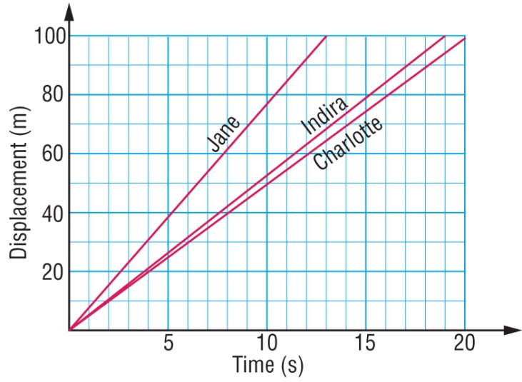

Select the alternative below that correctly orders their finish places in the race.

1. Jane wins, Indira is second and Charlotte is third.
2. Indira wins, Jane is second and Charlotte is third.
3. Charlotte wins, Indira is second and Jane is third.
4. Charlotte wins, Jane is second and Indira is third.

4. The greater the rebound height of a ball, the greater is the efficiency of energy transfer from gravitational potential to kinetic energy. Five balls are all dropped from a height of 2.0 m. The rebound height of each is listed in the table below.

|  |  |
| --- | --- |
| **Type of ball** | **Rebound height (m)** |
| Basketball | 1.42 |
| Tennis ball | 1.55 |
| Squash ball | 0.05 |
| Cricket ball | 0.68 |

The type of ball that transferred gravitational potential energy to kinetic energy the most efficiently in this test was the:

1. Basketball
2. Tennis ball
3. Squash ball
4. Cricket ball

5. The efficiency of a ball is the ratio of the rebound height and the height dropped. Use the table in the previous question to select the likely efficiency of the four balls tested.

|  |  |  |  |  |
| --- | --- | --- | --- | --- |
|  | **Efficiency of basketball** | **Efficiency of tennis ball** | **Efficiency of squash ball** | **Efficiency of cricket ball** |
| a) | 2.5 % | 34% | 78% | 71% |
| b) | 78% | 2.5% | 34% | 71% |
| c) | 34% | 71% | 78% | 2.5% |
| d) | 71% | 78% | 2.5% | 34% |



**Year 10**

**Science**

**Semester 1 Exam 2018 Part 2**

**MULTIPLE CHOICE ANSWER SHEET**

**NAME:**

**FORM: DATE:**

**SECTION ONE: Multiple choice answers**

**Cross (X) through the correct answer.**

|  |  |  |  |  |  |  |  |  |  |  |
| --- | --- | --- | --- | --- | --- | --- | --- | --- | --- | --- |
| **1** | **a** | **b** | **c** | **d** |  |  |  |  |  |  |
| **2** | **a** | **b** | **c** | **d** |  |  |  |  |  |  |
| **3** | **a** | **b** | **c** | **d** |  |  |  |  |  |  |
| **4** | **a** | **b** | **c** | **d** |  |  |  |  |  |  |
| **5** | **a** | **b** | **c** | **d** |  |  |  |  |  |  |
|  |  |  |  |  |  |  |  |  |  |  |
|  |  |  |  |  |  |  |  |  |  |  |
|  |  |  |  |  |  |  |  |  |  |  |
|  |  |  |  |  |  |  |  |  |  |  |
|  |  |  |  |  |  |  |  |  |  |  |
|  |  |  |  |  |  |  |  |  |  |  |
|  |  |  |  |  |  |  |  |  |  |  |

**SECTION TWO - SHORT ANSWER SECTION**  [22 marks]

This section has **4** questions. Answer **all** questions in the spaces provided. __________________________________________________________________________________________________________

**Question 1.**

Classify the following substances according to the types of bonds present (3 marks)

$2 coin __________________________ table salt _______________________

carbon dioxide _________________________

**Question 2.**

Having dimples (D) in your cheeks is dominant to having no dimples (d).

1. Circle the correct response which occurs either before or after the forward slash. (3 marks)

Dimples is an example of a dominant/recessive trait

The child with no dimples is

homozygous/heterozygous

Incomplete/Codominance is when both traits are dominant and displayed separately in the phenotype

1. The gene for coat colour in cats is carried on the X chromosome. There are two alleles, black (B) and orange (O). These two alleles are codominant.

The genotypes of XBXB and XBY result in black cats

The genotypes of XOXO and XOY result in orange cats

The genotype of XBXO results in a tortoise shell cat

A female tortoise shell cat produces in her litter 1 black female, 3 tortoise shell females, 1 black male, and one orange male. Determine **the genotype of the father** **cat** using a Punnett square to support your answer (4 marks)

**Question 3.**

Car racing is very popular in Australia. Many young people want to test the speed of their cars and meet regularly at racetracks. An oval racetrack has a lap distance of 2 000 m. The car has to complete 5 laps.

a) In one of the races a car has a running start. The timekeeper starts the stopwatch as the car passes the starting point. The results are shown in the table below.

|  |  |
| --- | --- |
| Number of laps | Time (s) |
| 1 | 55 |
| 2 | 110 |
| 3 | 165 |
| 4 | 275 |
| 5 | 385 |

On the graph paper provided **draw a graph** of the number of laps (on the dependent y-axis) versus time (on the independent x-axis) for the car's run.

1. Plot the points and connect them with straight lines. Also supply a suitable heading.

(5 marks)

1. How does the motion of the car during the first three laps compare with its motion in

the last two laps? (1 mark)

________________________________________________________________________________________________________________________________________________________________________________________________________________________

____________________________________________________________________________________________________________

**Question 4.**

**Work= f** x **d Gravitational Potential Energy (J) = m** x **g** x **h** where g=9.8 m/s

**Kinetic Energy = 0.5 x m x v2**

1. A bullet of mass 80 g that leaves a rifle with 250J of kinetic energy. Calculate the velocity of the bullet as it leaves the rifle. (3 marks)
2. A washing machine loses 134J of energy when supplied with 1832 J. Calculate the efficiency of the washing machine and state why the efficiency isn’t 100%. (3 marks)

**END OF PAPER**